**IBM ASSESSMENT**

**Circuit Connection:**

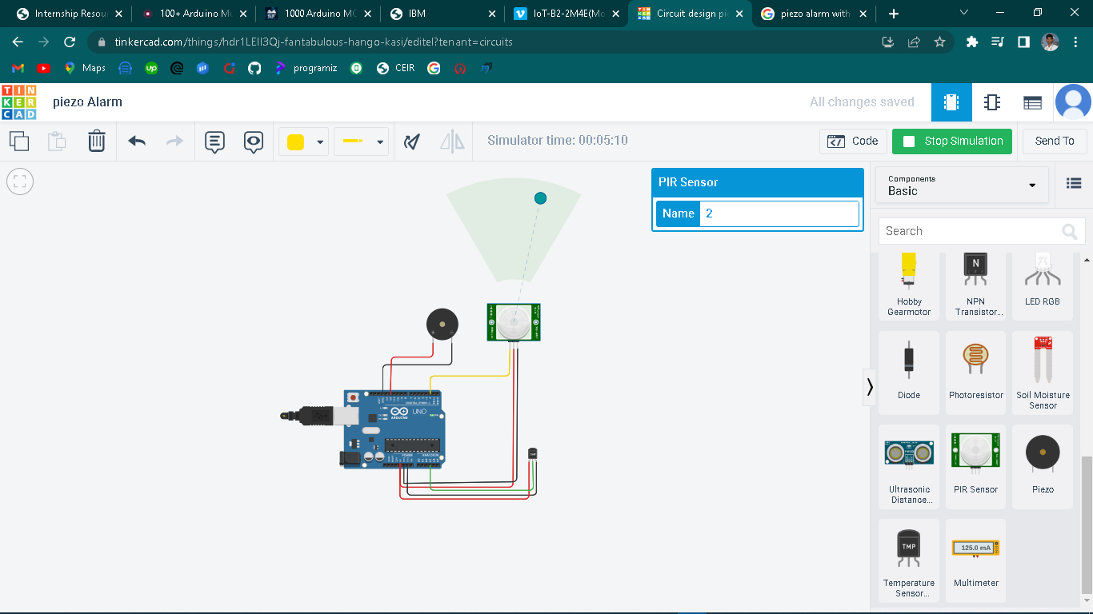

**Code:**

//c++ code

//

void setup()

{

Serial.begin(9600);

pinMode(2,INPUT);

pinMode(12,OUTPUT);

}

void loop()

{

int freq1=200,freq2=700;

int n=digitalRead(2);

Serial.print("motion");

Serial.println(n);

delay(1000);

double temp=analogRead(A3);

double n1=temp/1024;

double vout=n1*5;

double off=vout-0.5;

double temperature=off*100;

Serial.println(temperature);

if(temperature>=60)

{

tone(6,freq2,1000);

}

else if(n==1)

{

tone(6,freq1,1000);

}

}

Output:

